## Project Tender

# Project: Chat for Linphone

Kobus Coetzee

Team: Men at Work

Ivan Henning (13008219)

Muller Potgieter (12003672)

Johan van Rooyen (11205131)

Herman WillemKeuris (13037618)

Department of Computer Science, University of Pretoria

Date: 2015-05-04

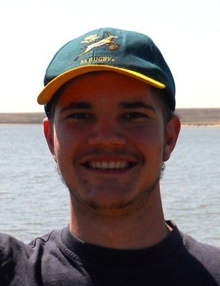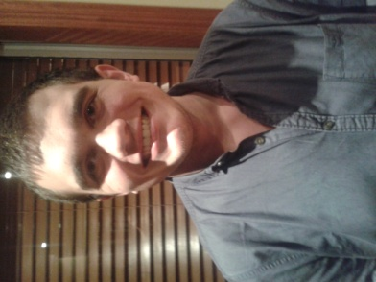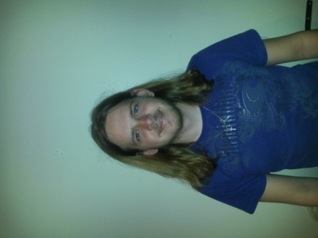

# The Team

## Ivan Henning



### Interests

* IT programming
* Latest technology
* Gaming
* Sport (cricket, rugby and hockey)

### Technical Skills

Experienced in coding in the following languages/mark-ups/standards:

C, C++, C#, Java, Pascal, HTML, CSS, XML, XSLT, JavaScript, JNode, PHP, AJAX, JQuery and MySQL.

Experience in working in the following fields:

* Operating Systems
* Networks
* Website Development
* Web Systems (server- and client side processing)
* Database management

### Past Experiences

* I am experienced in C and Java and have worked on the open source operating system MINIX.
* Have also worked on a small server and client program sending text messages to each other.

### Non-technical Strengths

* Work well in a team to accomplish goals.
* Quick learner.
* Organised.
* Work well under pressure.
* I'm realistic and debate matters logically.
* Task orientated and objective.
* Thinks outside of the box.

### What makes you want to do the project?

The project about Instant Messaging, which is the buzz word at the moment and is getting bigger every day, looks interesting and would present a challenge especially as it involves the latest technology and apps that people use in their daily lives. My past experience gained would come in very handy in completing this project and the experience that I'll gain would be valuable in the future.

## Joseph Jurgen Muller Potgieter



### Interests

* Reading
* Computer Games
* Documentaries

### Technical Skills

* C++ and C
* Java
* HTML, CSS and Javascript Coding
* PHP Development
* SQL Programming (Database Management)

### Past Experiences

* Worked in team projects for university assignments.
* Competed in public speaking, meaning I am comfortable in such situations

### Non-technical Strengths

* Comfortable in groups
* Good time manager
* Dedicated worker

### What makes you want to do the project?

The project seems as though it will present an interesting challenge and provide an educational experience that will benefit me in future endeavors.

## Johan van Rooyen

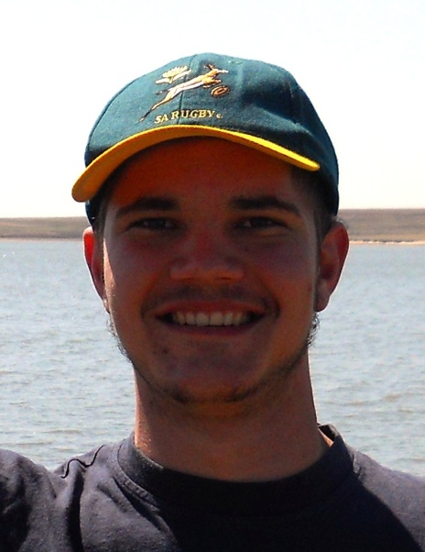

### Interests

* Fishing
* Hunting
* Adrenaline sports
* Computer Games
* Website design
* Electronic components and building small appliances

### Technical Skills

* C++ and C
* Java
* HTML, CSS and Javascript Coding
* PHP Development
* SQL Programming (Database Management)
* Novice Android Development
* Technical Support

### Past Experiences

* Worked as a web developer for 12 months in 2011, writing new and editing existing sites, managing resources on a remote server and working in weekly sprints to finish the project.
* Worked with an international team on a web design project, where meetings took place over Skype and collaborating through an private server made transfer of resources possible.

### Non-technical Strengths

* Good Communication skills
* Collaborate well with a team
* Good business knowledge
* Knowledge of Law in South Africa
* Good time management
* Organizational and Management skills
* Great problem solving abilities
* Go-getter
* Work well under pressure

### What makes you want to do the project?

This project will provide a good experience to me for future reference, since we will be working on an existing technology that is already out there and has been used by the public for quite some time. This will force me to work harder, as there is a lot of expectations to live up to and a lot of eyes on the project.

## Herman WillemKeuris



### Interests

* My two greatest interests are music and IT (especially Artificial Intelligence, Web design and multimedia orientated software).

### Technical Skills

Experienced in coding in the following languages/mark-ups/standards:

C, C++, Java, Python, Delphi, HTML, CSS, XML, JavaScript, JNode, PHP, AJAX, JQuery and MySQL

Experience in working in the following fields:

* Operating Systems
* Networks
* Web Systems (server- and client side processing)
* Database management

### Past Experiences

* I am very experienced in coding in C and Java and have some experience in working with simple operating systems which might prove useful when working with android systems.

### Non-technical Strengths

* Work well in group settings.
* Hard working.
* Practically orientated (like to plan out things in advance rather than progressing without clear goals or expectations).
* Good at abstracting complex data systems into more understandable and manageable segments.
* Quick learner.

### What makes you want to do the project?

I am very interested in programs associated with social media (e.g. social networking) and designing mobile applications. I’m also interested in how programs handle different types of multimedia (such as video and recordings) and would be very interested in learning more about, and using, Session Initiation Protocol elements. I’m also interested in the chance to learn more about cryptography in social applications such as IM’s.

# Project Execution

**Methodology:**

As the specification states we will be making use of the waterfall development methodology.

The waterfall method is a sequential and logical design process which “flows” through various stages of the software development process. Our design process will be split into the following phases:

* Requirements: Deciding on requirements.
* Design: Writing out requirements (System Requirements Document) and Design Documentation (including Plan for Software Aspects of Certification (PSAC) and Software Development Process (SDP) documents).
* Implementation: writing source code and Software Verification Cases and Procedures (SVCP).
* Verification: Testing and writing of the Software Versions Repository (SVR) (i.e. reviewing the code).
* Maintenance: Writing of the final reports such as the Statistical Analysis System document (SAS), the Software Configuration Management Record (SCMR) and a Software Quality Assurance document (SQA).

**Client communication:**

As stated in the specification we will be kept in constant contact with Kobus Coetzee in the form of emails and in person meetings every ±3 weeks (these meetings will be more frequent during the implementation phase). We will also make a GitHub repository available so that any interested party can keep tabs on our progress.

**Initial ideas:**

* Group chat:

Each group will have an admin user which can kick members and invite new members (optionally, all members could be admin members).

Each member in a group can have a distinct colour associated with their name to better distinguish their messages from the others.

* Profile: User profiles can have a profile picture and a custom (or default) status.
* Multimedia: Allow users to send pictures, videos, voice recordings, contacts and GPS locations to each other

**Technologies:**

As stated in the specifications, all development:

* will be done in a Linux environment
* using Eclipse IDE
* and the Android Developer Tools (ADT) plugin.

We will also be making use of the Zest T1 Android phones provided to us.

All source code will be coded in either C or Java.

**Final product:**

The final product will have the following functionality:

* Group chat (invite other members, delete members, delete groups, all members receive posts on the group).
* Secure communication thanks to basic message encryption.
* Voice recorder which immediately sends the recoding over the IM.
* Better GUI in general (pictures for the profiles, clear text, clearly indicate who said what, indicate what a user is doing, e.g. typing, online, last online, etc.)